Bar Code Specification

This document provides Senneca's guidelines on supply partner labels to be used for identifying material shipped to Senneca production facilities. The labels will be used to tie the contents of the shipment to an Advance Shipping Notice (ASN).

All production material shipments to Senneca facilities are to be accompanied by the following supply partner labels:

- Two Single Pack Labels are required on opposing sides of each container / box / package shipped (Figure 1).
- Master Pack Labels are required to summarize the contents of a pallet containing two or more containers / boxes / packages of the same part. All container labels on the pallet will be linked to the corresponding Master Label (Figure 2).
- The labels are based on the AIAG B-10 format.
  - The labels are 4 X 6-inches.
  - The barcodes are 3-of-9 (Code 39) type.
  - Font Style is Sans Serif
  - Fonts are sized based on LPB (Lines Per Block)
    - 2 LPB = .40 Inches (11mm)
    - 3 LPB = .25 Inches (7 mm)
    - 4 LPB = .20 Inches (5 mm)
    - 5 LPB = .15 Inches (4 mm)
    - 6 LPB = .12 Inches (3 mm)
    - 7 LPB = .10 Inches (2 mm)
    - 8 LPB = .08 Inches (1.5 mm)
  - Quiet Zone is .25 Inches
  - All Block Titles are 8 LPB
- For shrink-wrap packed pallets, the Master Label must be affixed to the outside of the shrink-wrap.
- Make sure that label placement on the container / box / package is facing forward and is easily scannable (Figure 3 and 4).
  - Labels should be placed on the side of the container with the bars perpendicular (+/-5 degrees) to the natural bottom of the container. When a label is placed on the top of a container, the bars should be perpendicular to the edge of the container and should not be placed over a seam.
  - Obsolete labels will be completely removed, defaced, or covered.

Block 2
Block 3
Block 4
Block 7
Block 8

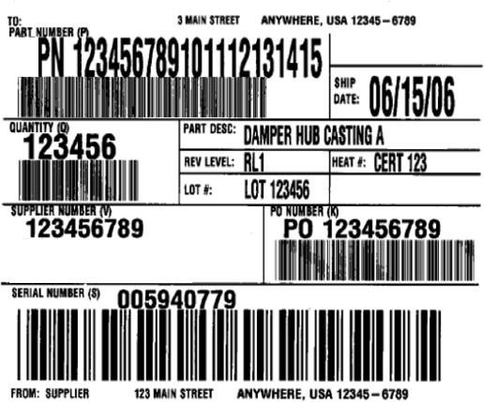Figure 1 - Single Pack Label
Block 1
Block 6
Block 5

Block 1:
Senneca Ship To Address

Block Title = TO:
Text Height = 8 LPB
Data = The address of the Senneca receiving location.

Senneca Part Number

Block Title = PART NUMBER (P) Data Identifier (DI) = P
Text Height = 2 LPB Barcode = .4 Inches
Data = Senneca's Part Number
Maximum Length = 25 characters + 1 character “P” DI Code

Block 2: QUANTITY:

Block Title = QUANTITY (Q) Data Identifier (DI) = Q
Text Height = 3 LPB Barcode = .4 Inches
Data = The quantity in this container / package / box Maximum Length = 6 characters + 1 character “Q” DI Code

Block 3: SUPPLIER NAME OR NUMBER:

Block Title = SUPPLIER (V) Data Identifier (DI) = V
Text Height = 3 LPB Barcode = .4 Inches
Data = Supplier Name or the assigned Senneca Supplier or Vendor Code. Maximum Length = 8 characters + 1 character “V” DI Code

Container Serial Number (if applicable)

Block Title = SERIAL NUMBER (S) Data Identifier (DI) = S
Text Height = 3 LPB Barcode = .7 Inches
Data = A unique serialized number for this container. Maximum Length = 10 characters + 1 character “S” DI Code

Supplier Ship From Address

Block Title = FROM:
Text Height = 8 LPB
Data = The address of the shipping location.

Block 5: EMPTY

Block 6: SHIP DATE:

Block Title = SHIP DATE:
Text Height = 2 LPB
Data = The date the shipment left your location. Format=MM/DD/YY

Senneca's Part Number Description

Block Title = PART DESC:
Text Height = 3 LPB
Data = Description of the Senneca's Part Number Maximum Length = 25 characters

Engineering Revision Level (if applicable)

Block Title = REV LEVEL:
Text Height = 3 LPB
Data = The Engineering Change Level of all parts in this container / box / package. Maximum Length = 10 characters.

Heat Certification Number (if applicable)

Block Title = HEAT #:
Text Height = 3 LPB
Maximum Length = 10 characters

Lot Number (if applicable)

Block Title = LOT #:
Text Height = 3 LPB
Data = Supplier assigned lot control number to that can be used to trace these parts to specific manufacturing/assembly process data Maximum Length = 10 characters.

Block 8: PO NUMBER:

Block Title = PO NUMBER (K) Data Identifier (DI) = K
Text Height = 3 LPB Barcode = .4 Inches
Data = Senneca assigned Purchase Order Number Maximum Length = 8 characters + 1 character "K" DI Code

Block 6

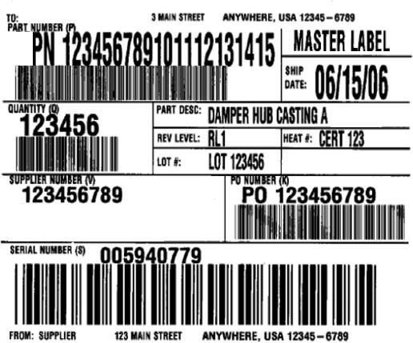Figure 2 - Master Pack Label

Block 1
Block 5

Block 2
Block 7

Block 3
Block 8

Block 4

Senneca Ship To Address

Block Title = TO:
Text Height = 8 LPB
Data = The address of the Senneca receiving location.

Senneca Part Number
Block Title = PART NUMBER (P) Data Identifier (DI) = P
Text Height = 2 LPB Barcode = .4 Inches
Data = Senneca's Part Number.
Maximum Length = 25 characters + 1 character “P” DI Code

Block 2: QUANTITY:

Block Title = QUANTITY (Q) Data Identifier (DI) = Q
Text Height =3 LPB Barcode = .4 Inches
Data = The total quantity in all containers on this master container / box / package Maximum Length = 6 characters + 1 character “Q” DI Code

Block 3: SUPPLIER NAME OR NUMBER:

Block Title = SUPPLIER (V) Data Identifier (DI) = V
Text Height = 3 LPB Barcode = .4 Inches
Data = Supplier Name or the Senneca assigned Supplier or Vendor Code. Maximum Length = 8 characters + 1 character “V” DI Code

Container Serial Number (if applicable)

Block Title = SERIAL NUMBER (4S)
Data Identifier (DI) = 4S Text Height = 3 LPB Barcode = .7 Inches
Data = A unique serialized number for this container. Maximum Length = 10 characters + 2 character “4S” DI Code

Supplier Ship From Address

Block Title = FROM:
Text Height = 8 LPB
Data = The address of the shipping location.

Block 5: MASTER LABEL

Block Title = MASTER LABEL Text Height = 2 LPB

Block 6: SHIP DATE:

Block Title = SHIP DATE:
Text Height = 2 LPB
Data = The date the shipment left your location. Format=MM/DD/YY

Block 7:

Senneca's Part Number Description

Block Title = PART DESC:
Text Height = 3 LPB
Data = Description of the Senneca Part Number Maximum Length = 25 characters

Engineering Revision Level (if applicable)

Block Title = REV LEVEL:
Text Height = 3 LPB
Data = The Engineering Change Level of all parts in this container / box / package. Maximum Length = 10 characters.

Heat Certification Number (if applicable)

Block Title = HEAT #:
Text Height = 3 LPB
Maximum Length = 10 characters

Lot Number (if applicable)

Block Title = LOT #:
Text Height = 3 LPB
Data = Supplier assigned lot control number to that can be used to trace these parts to specific manufacturing/assembly process data Maximum Length = 10 characters.

Block 8: PO NUMBER:

Block Title = PO NUMBER (K) Data Identifier (DI) = K
Text Height = 3 LPB Barcode = .4 Inches
Data = Senneca assigned Purchase Order Number Maximum Length = 8 characters + 1 character “K” DI Code

Figure 3 – Label Orientation

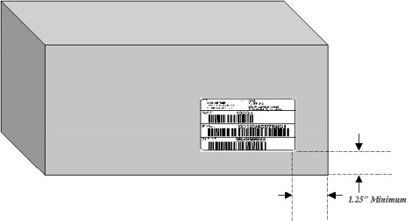

Figure 4 – Suggested Label Placement

